**Exploring venues in Lucknow, India**

**using Foursquare and Zomato API**

Utkarsh Bhardwaj

January 11, 2020

1. **Introduction**
   1. **Background**

Whenever a person searches for a venue in a new city, they’re highly interested in the best places that the city has to offer. The person might want to know how good a given restaurant is or the price range it falls under. This extra information would help decide which venue to choose amongst the many venues in the city. Combining the location of the venues in the city with their price and rating information would surely help visitors in a city make better informed decisions about the places they should visit.

Lucknow is composed of a number of sectors spread across a total area of 349 sq Km. There are many venues (especially restaurants, hotels and cafes) which can be explored. This project explores various venues in Lucknow and attributes the data based on user ratings and average price. To explore this information, this project involves the position of both the Foursquare API and the Zomato API to fetch complete information of various venues (including name, address, category, rating, and price). Further, a map of the venues with specific color attributes will be plotted to highlight their position, and information about these venues. Such plots imbibe bountiful information in the form of their colored representations and location on the map. This enables any visitor to take a quick glance and decide what place to visit.

* 1. **Interested audience**

The target audience for such a project is twofold. Firstly, any person who is visiting Lucknow, India can use the plots and maps from this project to quickly select places that suit their budget and rating preferences. Secondly, a company can use this information to create a website or a mobile application, which is updated on a regular basis, to allow individuals to the city or even expand same functionality to other places.

1. **Data**
   1. **Data Sources**

To get location and other information about various venues in Lucknow, I used two APIs and decided to combine the data from both of them together.

Using the Foursquare’s explore API (which gives venues recommendations), I fetched venues up to a range of 10 kilometers from the center of Lucknow and collected their names, categories and locations (latitude and longitude).

Using the name, latitude and longitude values, I used the Zomato search API to fetch venues from its database. This API allows to find venues based on search criteria (usually the name), latitude and longitude values and more. Given that the data from the two APIs did not align completely, I had to use data cleaning to combine the two datasets properly.

From Foursquare API (<https://developers.zomato.com/api>), I retrieved the following for each venue:

* **Name:** The name of the venue.
* **Category:** The category type as defined by the API.
* **Latitude:** The latitude value of the venue.
* **Longitude:** The longitude value of the venue.

From Zomato API (<https://developers.zomato.com/api>), I retrieved the following for each venue:

* **Name:** The name of the venue.
* **Address:** The complete address of the venue.
* **Rating:** The ratings as provided by many users.
* **Price range:** The price range the venue belongs to as defined by Zomato.
* **Price for two:** The average cost for two people dining at the place. I later convert the same to average price per person by dividing by 2.
* **Latitude:** The latitude value of the venue.
* **Longitude:** The longitude value of the venue.
  1. **Data Cleaning**

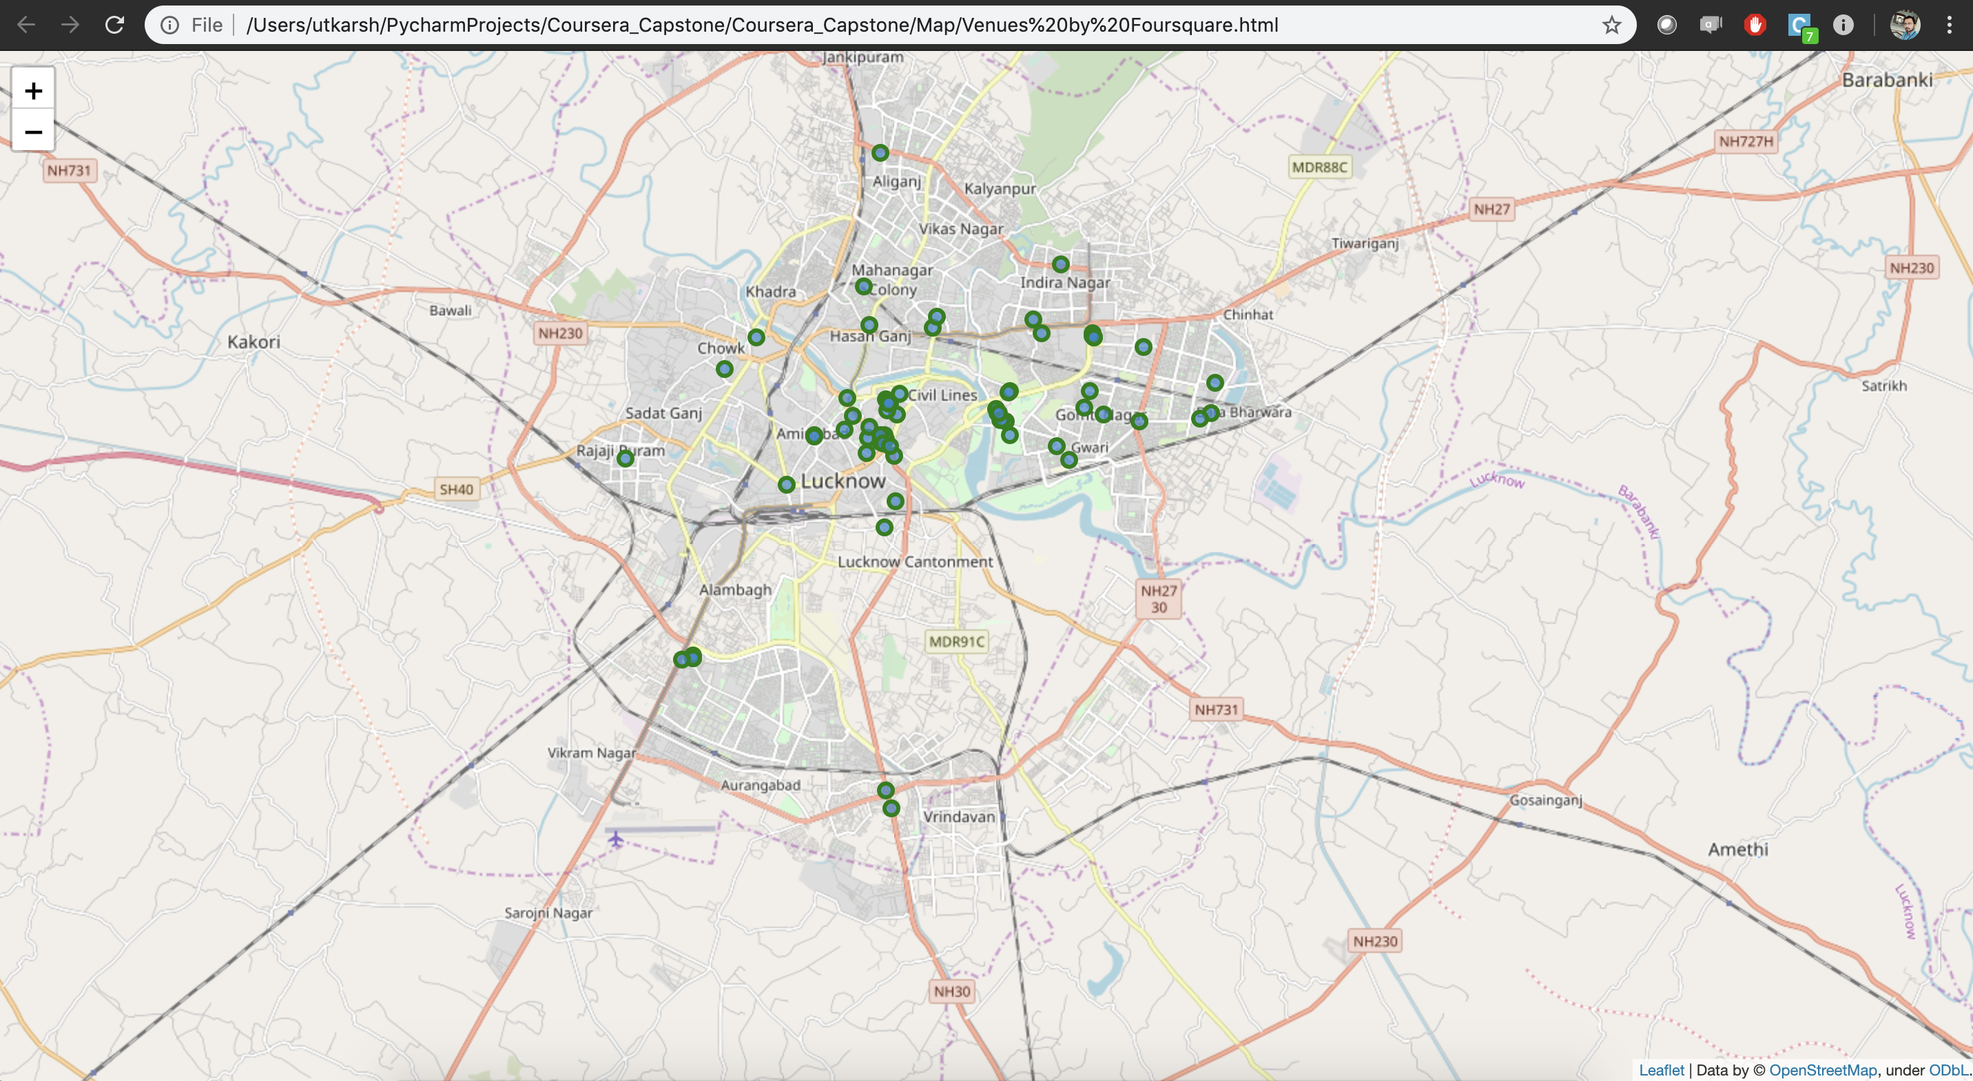

*Figure 1: Venues retrieved from Foursquare API*

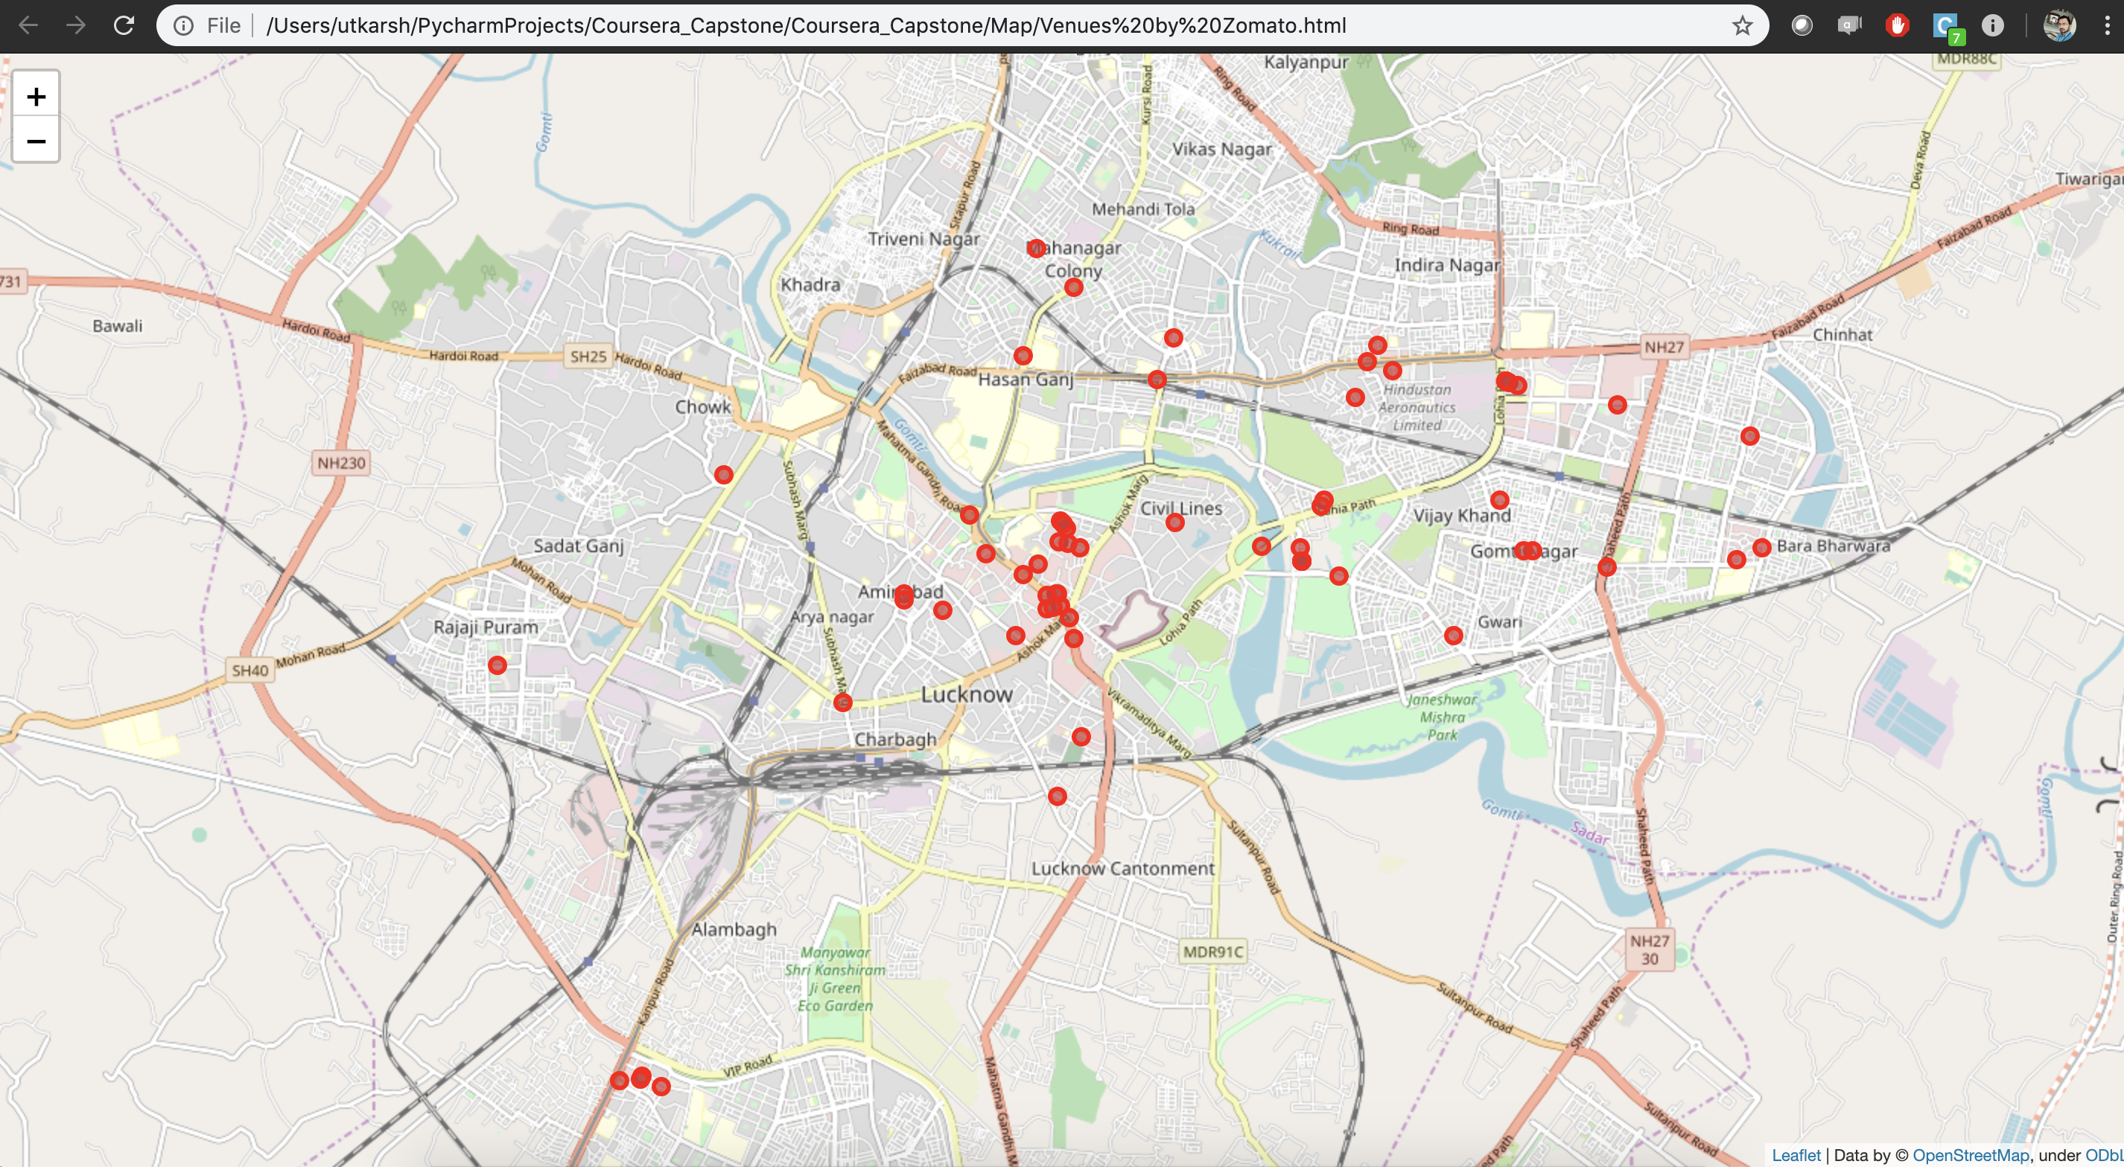

*Figure 2: Venues retrieved from Zomato API*

From figure 1 and figure 2, we can clearly see that some venues from the two APIs do not align with each other. Thus, I decided to combine them using their latitude and longitude values.

There are lot of overlapping between the two near **Sahara Mall, Hajaratganj and lohia park**. However, there are others where the data does not match just like the red dots in the top right on the second map (like area near Hasanganj,Vijaykhand)

To combine the two datasets, I'll have to check that the latitude and longitude values of each corresponding venue match. Thus, I'll round both the latitude and longitude values upto 4 decimal places. Then, I'll calculate the difference between the corresponding latitude and longitude values and see if the difference is less than 0.0004 which should ideally mean that the two locations are same.

They can be categorised as follows:

1. There are venues that have specific restaurants/cafes inside them as provided by Zomato API (Quality Like Five Star in Shopping Mall ,Janpath Market).
2. Some venues have been replaced with new venues (JJ Bakery has now been replaced by La Reine).

Venues belonging to category 1 and 2 are perfect to keep. After careful inspection and removal(whose rating 0), the final dataset had a total of 34 venues with which we can work.

As a final dataset, we’re left with 34 venues with 8 columns as described in figure 3.

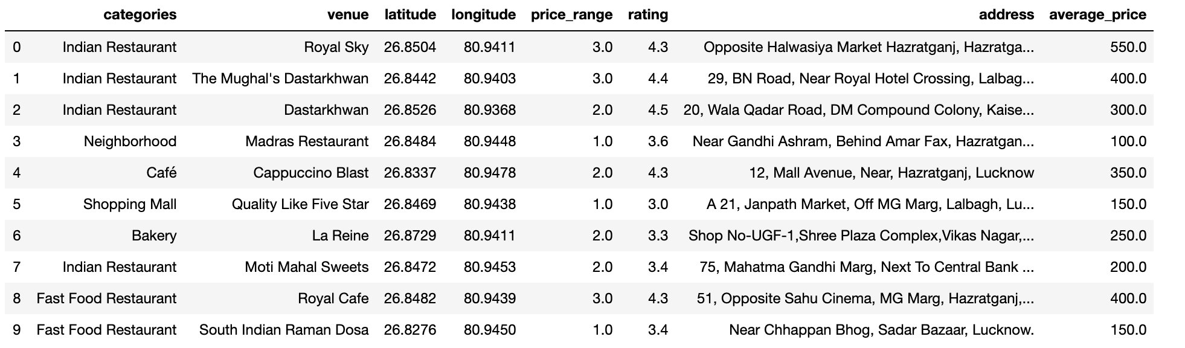

*Figure 3: Final data aggregated from both APIs*